Dashboard view – Townsville_QLD
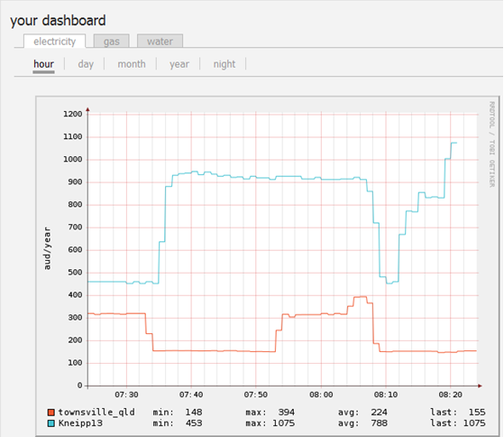
Dashboard view below Kneippl3 – taken at the same time
